<AHB-Lite >

AMBA AHB-Lite Master IP

Version 1.0

Block Owner
Amr Hesham Awad Soliman
Authors
Amr Hesham Awad Soliman

Table of Contents

1. Overview
2. Functional Description
2.1 Master
2.2 Slave (AHB-to-Peripheral Interface)
3. Block Diagram
3.1 Master_Architeture
3.2 Master_FSM_Digram
4. Finite State Machine (FSM) Description
5. CPU Interface and Internal Control Signal Description
6. Peripheral Interface Signal Description
7. Timing Diagram
7.1 Single Write and Single Read Transfers
7.2 INCR4 Burst Write and Read Operations
7.3 Back-to-Back (B2B) Write and Read (Zero Wait States)
7.4 Pipeline Stall: Back-to-Back Transfers with Wait States
7.5 Burst Error Recovery (Slave Error Response)
7.6 Synopsys SpyGlass Lint and CDC Analysis Setup
8. Verification Requirements
8.1 Reset and Initialization
8.2 Basic Single Transfers
8.3 Burst Operations & Boundary Mapping
8.4 Pipelining and Back-to-Back (B2B) Transactions
8.5 Wait States and Stall Handling
8.6 Error Handling and Recovery
8.7 Peripheral Interface Translation

Overview
The AMBA AHB-Lite Master IP is a highly efficient, synthesizable SystemVerilog Intellectual Property (IP) core designed to implement the ARM AMBA 3 AHB-Lite protocol. It serves as a high-performance, low-latency communication bridge that initiates read and write transactions between a host processor (CPU) and downstream AHB-Lite slaves or memory-mapped peripherals.
Designed with modularity and robust verification in mind, the architecture revolves around a centralized Finite State Machine (FSM) that meticulously orchestrates bus pipelining. The design incorporates dedicated hardware sub-blocks, including a dynamic Address Generator, Burst Counter, pipelined Read/Write Data Buffers, and Exception/Timeout handling units.
Key Features & Capabilities:
- Protocol Compliance: Fully conforms to the AMBA 3 AHB-Lite bus specification.
- Transfer Types: Supports basic Single transfers as well as advanced Burst transfers, including Incrementing (INCR4) and Wrapping (WRAP4) bursts.
- High-Bandwidth Pipelining: Achieves maximum bus utilization by supporting zero-wait state, Back-to-Back (B2B) transactions with perfect Address and Data phase overlapping.
- Dynamic Stall Handling: Seamlessly manages pipeline freezing and data stability through wait-state injection using the HREADY handshake signal.
- Robust Error Recovery: Features instant error detection via the HRESP (or P_ERROR) signal, enabling automatic burst abortion and safe FSM recovery without system deadlock.
- Configurability: Fully parameterized data width (Data_Width = 32 by default) and supports dynamic transaction parameters including transfer size (HSIZE) and burst type (HBURST).
- Implementation Readiness: The RTL is written following strict synchronous design guidelines (STARC), ensuring a clean Linting profile and readiness for Clock Domain Crossing (CDC) integration in both ASIC and FPGA environments.
This IP block is optimized for embedded System-on-Chip (SoC) architectures requiring a reliable, fast, and lightweight master interface to control peripheral ecosystems.

2. Functional Description

2.1 Master
The AHB-Lite Master controls all bus transactions through a Finite State Machine (FSM). When a transfer request is received, the FSM initializes the transaction by loading the start address and burst information.
During the transfer state, the master performs read or write operations depending on the HWRITE signal. For each successful transfer (HREADY = HIGH), the Address Generator updates the current address while the Burst Counter decrements the remaining transfer count.
The Read Buffer captures incoming data from HRDATA during read operations, while the Write Buffer supplies HWDATA during write operations.
The Timeout Unit monitors HREADY and generates an error if the slave remains busy longer than the configured timeout period.
When all transfer beats are completed, the FSM enters the DONE state before returning to the IDLE state. If an error response is detected, the FSM transitions to the ERROR state to terminate the current transaction.

2.2 Slave (AHB-to-Peripheral Interface)
The AHB-Lite Slave acts as the interface between the high-speed AHB bus and the slower downstream peripherals. It continuously monitors the bus and initiates a transaction when it is selected (HSEL = HIGH) and a valid transfer is detected (HTRANS indicates NONSEQ or SEQ). During this initial Address Phase, the slave samples the address and control signals to prepare for the subsequent operation.
During the Data Phase, the slave executes the requested read or write operation based on the sampled HWRITE signal. It translates the AHB protocol into the appropriate peripheral control signals (such as P_ENABLE and P_WRITE) to facilitate the data exchange.
For write operations, the slave captures the incoming data from the HWDATA bus and routes it to the peripheral's data input (P_HWDATA). Conversely, for read operations, it retrieves the data from the peripheral (P_HRDATA) and drives it onto the HRDATA bus for the master to capture.
If the downstream peripheral requires additional time to process the data, the slave utilizes the P_READY signal to insert wait states. By driving the bus HREADYOUT signal LOW, it stalls the master's pipeline until the peripheral is ready to complete the transfer, ensuring synchronous data alignment.
Upon successful completion of the transfer beat, the slave prepares for the next sequential or non-sequential transaction. If the peripheral encounters an invalid access or internal fault, it raises the P_ERROR signal. The slave immediately propagates this error response back to the master, allowing the system to safely abort the transaction and handle the exception.

3. Block Diagram

3.1 Master_Architeture

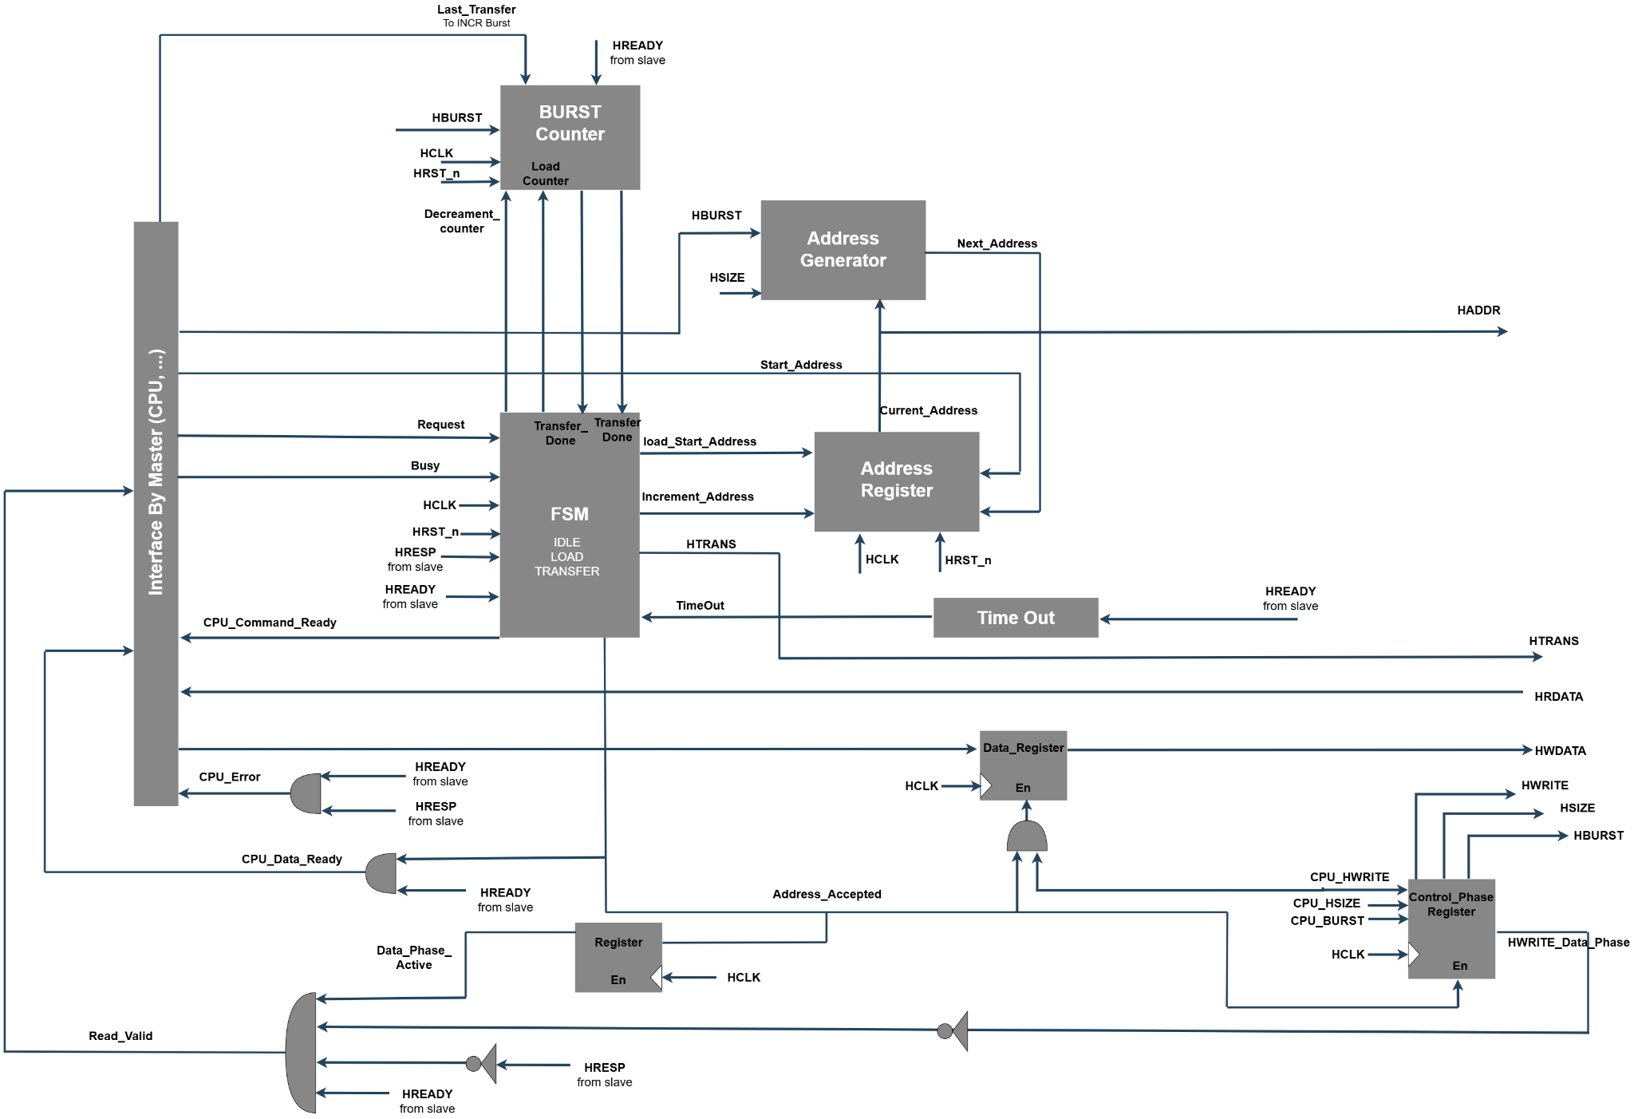

3.2 Master_FSM_Digram

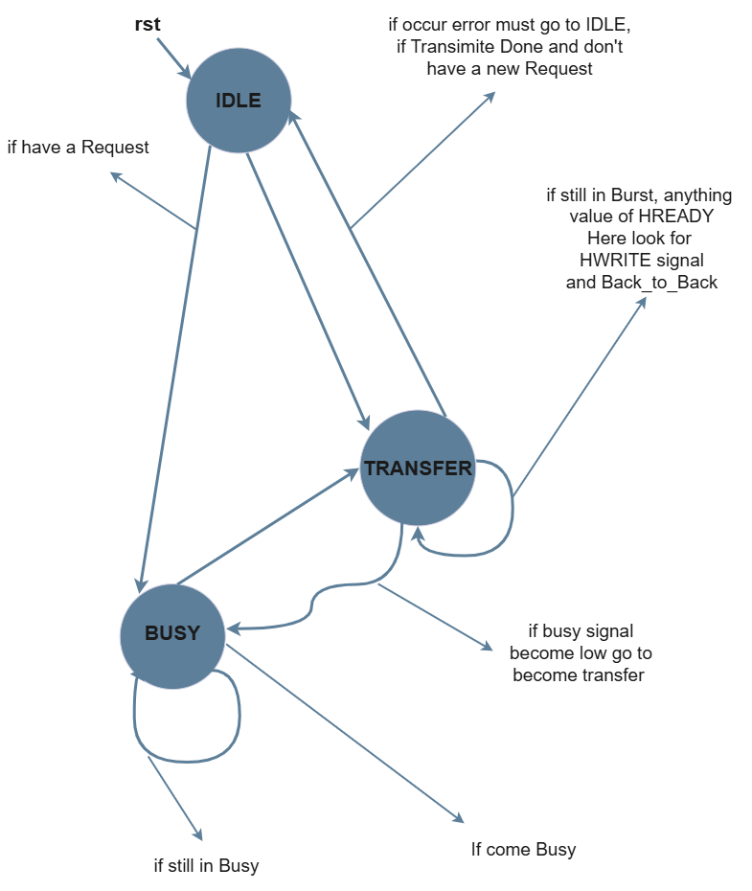

4. Finite State Machine (FSM) Description
The AHB-Lite Master operates using a Finite State Machine (FSM) consisting of three primary states: IDLE, TRANSFER, and BUSY. This state machine governs the flow of all bus transactions, handles burst sequences, back-to-back operations, and manages error recovery.
- IDLE State: The FSM enters the IDLE state immediately upon a system reset (rst). It remains in this default state as long as there are no pending transactions. When a new transfer request is initiated ("if have a Request"), the FSM transitions directly to the TRANSFER state. Alternatively, if a request coincides with a busy condition, the FSM can transition directly to the BUSY state.
- TRANSFER State: This is the active operational state where data reads, writes, and burst beats are executed. The FSM remains in this state as long as it is processing a burst transaction ("if still in Burst"), evaluating the HREADY and HWRITE signals to manage consecutive beats and pipelined back-to-back transfers. The FSM exits the TRANSFER state under three conditions:
  - It returns to the IDLE state if the current transmission is successfully completed ("Transimite Done") and there is no new pending request.
  - It forcibly returns to the IDLE state to abort the transaction if a bus error occurs.
  - It transitions to the BUSY state if the master requires wait states before completing the current or next transfer.
- BUSY State: The FSM enters the BUSY state from either IDLE or TRANSFER when the master is temporarily unable to proceed with the transaction. The FSM loops within this state, effectively stalling the transfer pipeline, as long as the busy condition persists ("if still in Busy"). Once the master is ready and the busy signal becomes low, the FSM transitions to the TRANSFER state to resume the transaction.

5. CPU Interface and Internal Control Signal Description

Signal Name | Port Width | Type / Scope | Description
CPU_Command_Ready | 1-bit | Output Interface | Indicates that the AHB Master has successfully accepted the CPU command and captured all required control information (address, burst type, transfer size, and transfer direction). When asserted, the CPU may issue the next transaction request.
CPU_Error | 1-bit | Output Interface | Indicates that the current transaction has terminated due to an unrecoverable error, such as an AHB error response (HRESP) or a timeout condition. When asserted, the current transfer is aborted and the CPU is notified of the failure.
CPU_Data_Ready | 1-bit | Output / Handshake | Handshake signal indicating that the current write data has been accepted by the AHB Master and the CPU may present the next data word during burst write transfers. (Remove this row if the signal is no longer used in the final design.)
Read_Valid | 1-bit | Internal Control | Indicates that the read data available on HRDATA is valid and can be safely captured by the processor or read buffer. Asserted only during successful read data phases.
HWRITE_Data_Phase | 1-bit | Internal Pipeline | Registered version of the HWRITE control signal captured during the address phase and propagated into the corresponding data phase. It identifies whether the active data phase represents a read or write transfer.
Data_Phase | 1-bit | Internal Status | Indicates that the AHB Master is currently executing the data phase of a transfer. During this phase, write data (HWDATA) is transmitted or read data (HRDATA) is received while the next address phase may already be in progress.
Capture_Control_Signal | 1-bit | Internal Control | Internal enable signal generated during the LOAD state to capture the transaction control information (such as HWRITE, HBURST, and HSIZE) from the CPU interface into internal pipeline registers before starting the transfer.
Data_Phase_Active | 1-bit | Internal Status | Indicates that a valid data phase is currently active. It remains asserted while the master is processing the data phase of the current transaction and is cleared when the transfer completes or is terminated by an error or timeout. (Remove this row if the signal has been removed from the final RTL.)

6. Peripheral Interface Signal Description

Signal Name | Port Width | Type / Scope | Description
P_ADDR | 32-bit | Output Interface | Indicates the physical address for the current read or write transfer directed to the downstream peripheral.
P_HWDATA | Data_Width-bit | Output Interface | Carries the write data transferred from the AHB master to be written into the peripheral during a write operation.
P_WRITE | 1-bit | Output Interface | Indicates the transfer direction. When asserted HIGH, the current transaction is a write operation. When LOW, it is a read operation.
P_ENABLE | 1-bit | Output Interface | Acts as an active enable strobe. Indicates that the interface is in the active data phase of the transfer, commanding the peripheral to execute the read or write.
P_HRDATA | Data_Width-bit | Input Interface | Carries the read data provided by the peripheral back to the slave during a read operation. This data is safely captured and considered valid only when P_READY is HIGH.
P_READY | 1-bit | Input / Handshake | Handshake signal driven by the peripheral to indicate that it has completed the transfer. When LOW, it inserts wait states, stalling the AHB bus pipeline until the peripheral is ready.
P_ERROR | 1-bit | Input Interface | Indicates that the current transaction has terminated due to a peripheral-level error (e.g., access violation or unsupported address). When asserted, the slave propagates an error response back to the AHB Master to safely abort the transfer.

7. Timing Diagram

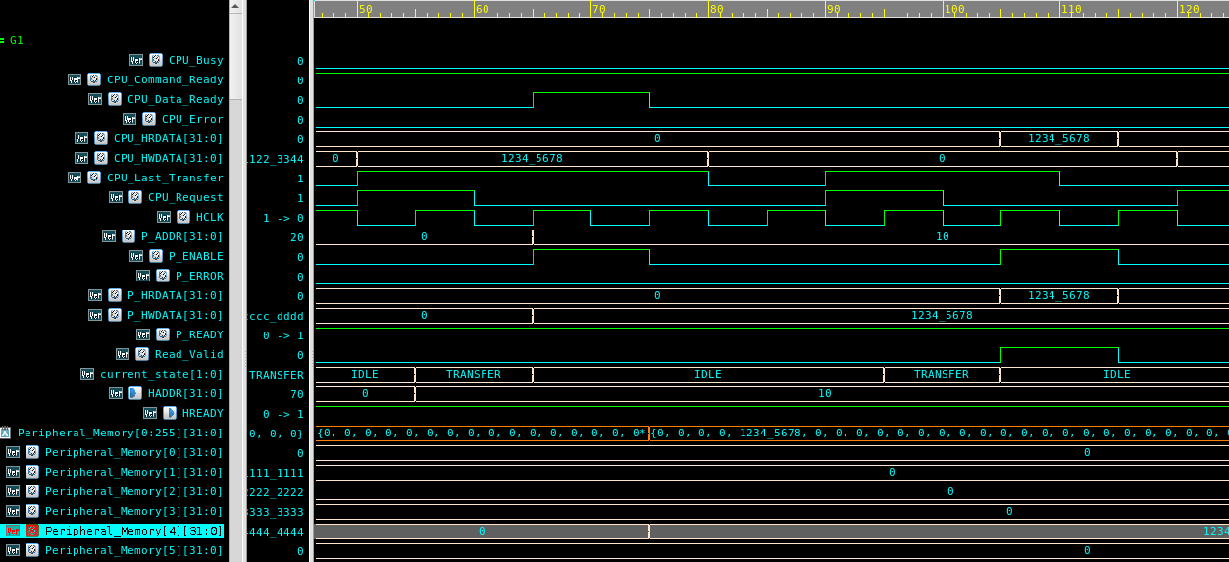

7.1 Single Write and Single Read Transfers

Description: This waveform demonstrates fundamental single-beat write and read transactions over the AHB bus with zero wait states.
Key Signals: The transaction is initiated by the CPU_Request signal. The AHB pipelining mechanism is clearly visible, where the Address Phase (P_ADDR, P_WRITE, P_ENABLE) is issued exactly one clock cycle before the Data Phase (P_HWDATA for writes, P_HRDATA for reads).
Observation: The Master successfully writes the data 1234_5678 to address 0x10 and subsequently reads the exact same data back in the following operation. The FSM transitions smoothly into the TRANSFER state and back to IDLE.

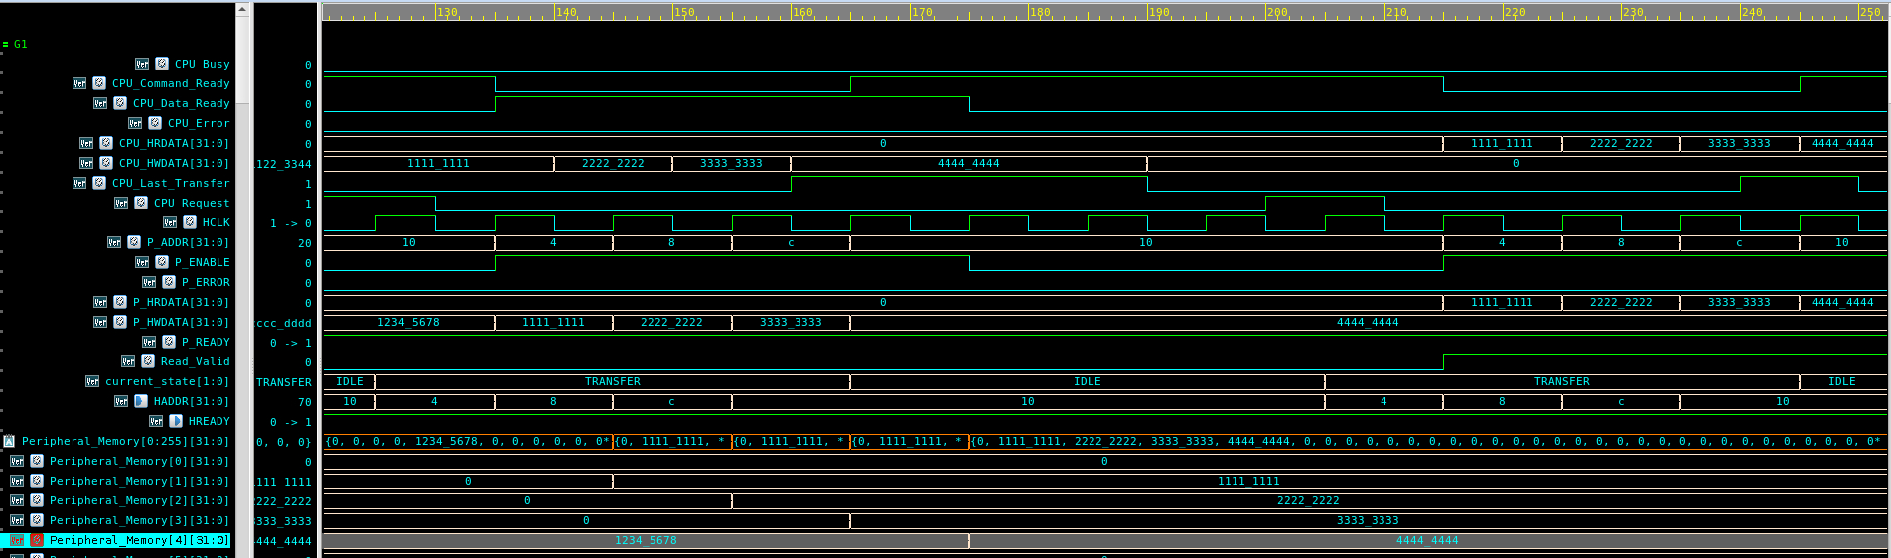

7.2 INCR4 Burst Write and Read Operations

Description: This test illustrates a 4-beat incrementing burst (INCR4) without any wait states, proving the efficiency of the data pipeline.
Key Signals: The CPU_HBURST is configured for an INCR4 transfer. The CPU_Data_Ready signal acts as the synchronizer between the CPU and the Master FSM, requesting the next word in the burst.
Observation: Seamless pipelining is achieved. The address for Beat N is successfully driven onto the bus concurrently with the data for Beat N-1. Four distinct 32-bit data words (1111_1111 to 4444_4444) are written to sequential addresses and correctly read back in the subsequent burst operation.

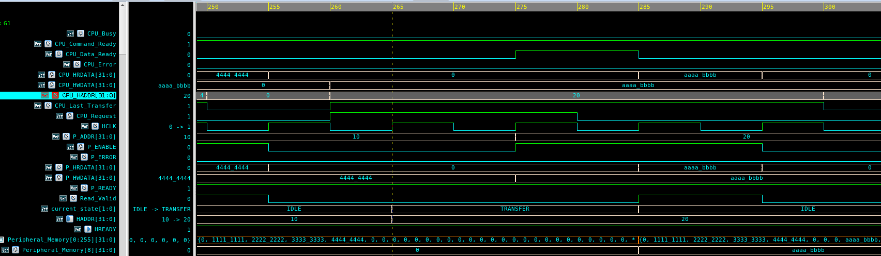

7.3 Back-to-Back (B2B) Write and Read (Zero Wait States)
Description: This scenario verifies the Master's ability to transition immediately from a Write operation directly into a Read operation without wasting clock cycles on an IDLE state.
Key Signals: The CPU_Request signal remains asserted high between the two commands to bridge the transfers.
Observation: The Master recognizes the back-to-back request and jumps directly from one TRANSFER state to the next. The Address Phase of the Read transaction (ADDR = 20) overlaps perfectly with the Data Phase of the preceding Write transaction (DATA = aaaa_bbbb), maximizing bus utilization bandwidth.

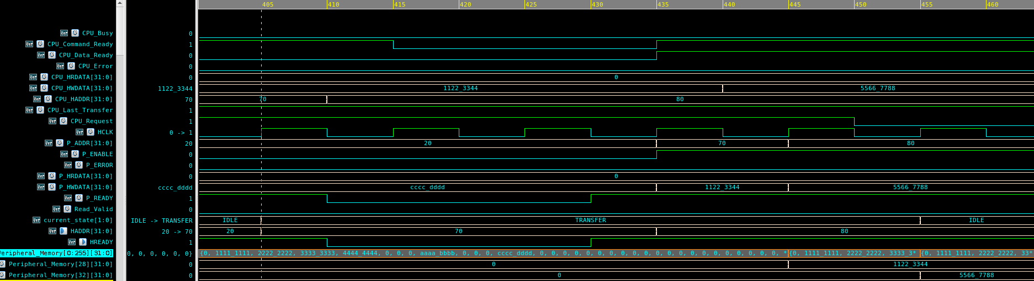

7.4 Pipeline Stall: Back-to-Back Transfers with Wait States
- Description: These waveforms evaluate the robustness of the Master's pipeline when the Slave asserts wait states during continuous operations.
- Key Signals: The HREADY (or P_READY) signal is driven low (0) by the Slave, forcing the bus to stall.
- Observation: The Master successfully freezes its internal registers. It holds the current data phase (e.g., 1122_3344) and the subsequent address phase completely stable for the duration of the 2-cycle stall. Once HREADY is re-asserted high, the pipeline resumes smoothly and transmits the next data word (5566_7788) without any data loss, overlapping, or corruption.

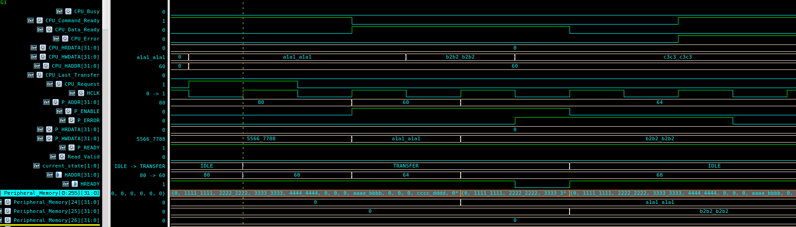

7.5 Burst Error Recovery (Slave Error Response)

- Description: This test proves the Master's exception handling and recovery capabilities when the Slave issues a fatal Error response in the middle of a burst transfer.
- Key Signals: The P_ERROR signal is maliciously injected high during the Data Phase of the second beat in an INCR4 burst.
- Observation: The Master FSM instantly detects the active error signal and safely aborts the remainder of the burst. It cancels the pending data writes, flags the CPU_Error signal high to alert the processor, and safely drops back to the IDLE state, preventing system lockup.

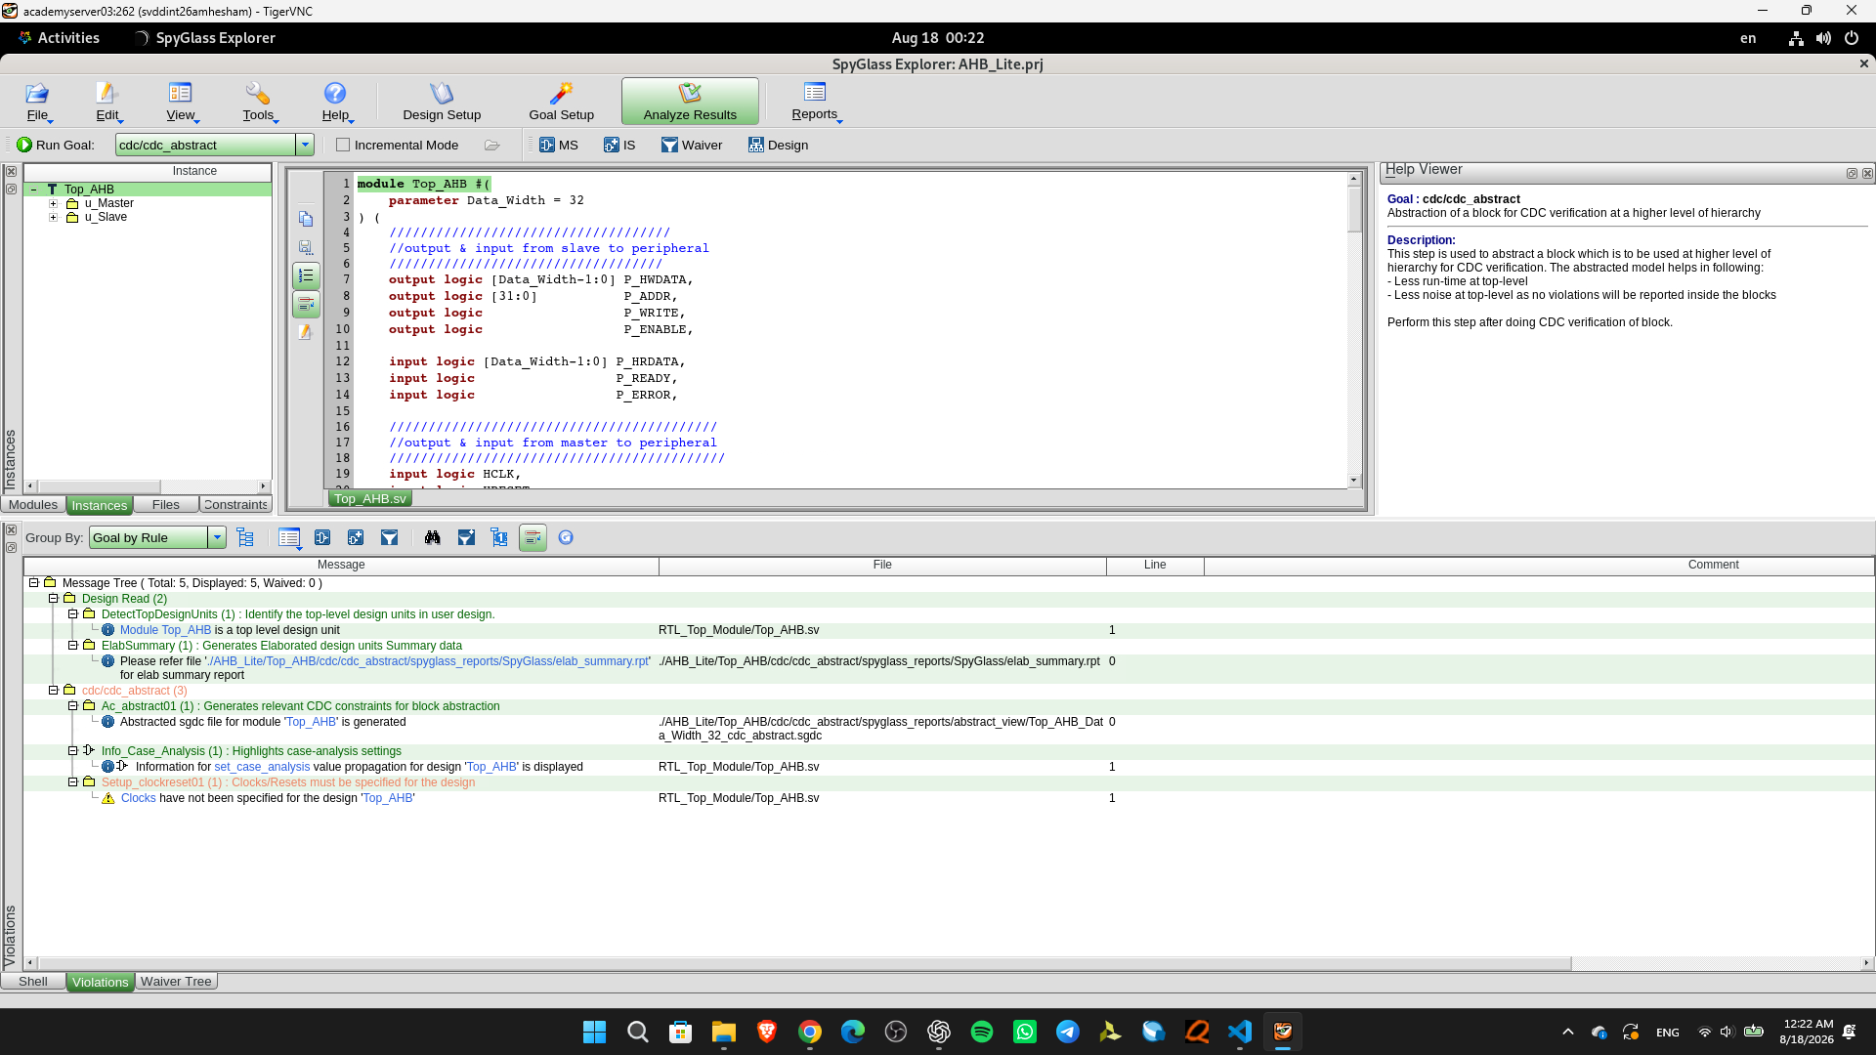

7.6 Synopsys SpyGlass Lint and CDC Analysis Setup
- Description: This screenshot captures the initial setup phase of static structural analysis and Clock Domain Crossing (CDC) verification using Synopsys SpyGlass. The tool is actively evaluating the top-level RTL module (Top_AHB) under the cdc/cdc_abstract goal.
- Observation: The analysis reports a fundamental setup warning in the message tree: Setup_clockreset01: Clocks have not been specified for the design 'Top_AHB'. Because SpyGlass performs rigorous static analysis, it does not assume signal roles based purely on naming conventions (e.g., HCLK or HRESET_n). Consequently, the tool pauses deep CDC structural analysis until the primary clock and reset domains are explicitly defined.
- Action Required: To resolve this warning and proceed with comprehensive CDC verification, a SpyGlass Design Constraints (SGDC) file must be provided to the tool. This file will explicitly declare HCLK as the system clock and HRESET_n as the active-low reset, enabling SpyGlass to accurately construct its abstraction model and verify safe clock domain crossings.

8. Verification Requirements
This section outlines the functional features, protocol rules, and corner cases that must be explicitly tested and verified to ensure the AHB-Lite Master, Slave, and Peripheral interfaces operate correctly according to the system specifications. The verification environment must fulfill and achieve full coverage for the following requirements:

1. Reset and Initialization
- Verify that upon system reset (HRESET_n = LOW), the Master FSM enters the IDLE state immediately.
- Ensure all bus control signals are driven to their default benign values during the reset period.

2. Basic Single Transfers
- Single Write: Verify successful single-beat write operations to the peripheral memory with zero wait states.
- Single Read: Verify successful single-beat read operations from the peripheral memory, ensuring data is sampled correctly by the master.

3. Burst Operations & Boundary Mapping
- INCR4 Execution: Verify the proper execution of 4-beat incrementing bursts (INCR4) for both read and write operations with zero wait states.
- WRAP4 Execution (Wrapping Bursts): Verify that the Master can correctly handle 4-beat wrapping bursts (WRAP4) where the address wraps around when reaching the burst boundary.
- Address Boundary Calculation: Ensure that for WRAP4 transfers, the Address Generator accurately calculates the wrapping boundary based on the transfer size (e.g., for a Word transfer HSIZE = 010, a WRAP4 burst wraps at 16-byte boundaries: 0x0 -> 0x4 -> 0x8 -> 0xC then wraps back to 0x0).
- Data Alignment: Verify that data beats are aligned perfectly with the wrapped addresses and no data overwriting occurs during the wrap-around boundary clock cycle.
- Address Generation: Ensure that the Master internally generates and drives the correct sequential addresses for each beat of any burst transfer.

4. Pipelining and Back-to-Back (B2B) Transactions
- Zero-Idle Transitions: Verify that the Master can seamlessly transition from a Write to a Read (and Write to Write) without inserting unnecessary IDLE cycles.
- Phase Overlapping: Ensure that the Address Phase of a pending transaction overlaps correctly with the Data Phase of the active transaction without data corruption.

5. Wait States and Stall Handling
- Slave Stalls: Verify that the Master FSM correctly freezes its pipeline when the Slave/Peripheral requires additional time (P_READY = LOW).
- Data Stability: Ensure that the Master securely holds the current Data Phase and the subsequent Address Phase stable for the entire duration of the wait states, resuming smoothly once P_READY is HIGH.

6. Error Handling and Recovery
- Error Detection: Verify that the Master successfully detects an active error response (P_ERROR = HIGH) from the slave.
- Burst Abortion: Ensure that if an error occurs in the middle of a burst (e.g., Beat 2 of an INCR4), the Master aborts the remaining beats immediately.
- CPU Notification: Verify that the Master asserts the CPU_Error signal to alert the processor and gracefully transitions back to the IDLE state to prevent system lockup.

7. Peripheral Interface Translation
- Verify the correct translation of AHB bus signals into the peripheral-specific control signals (P_ENABLE, P_WRITE, P_ADDR, P_HWDATA), ensuring a correct APB-like handshake.

